Topic 2 : 

Lesson 1 : Download JDK

1. To download JDK [click Here](https://www.oracle.com/java/technologies/downloads/).

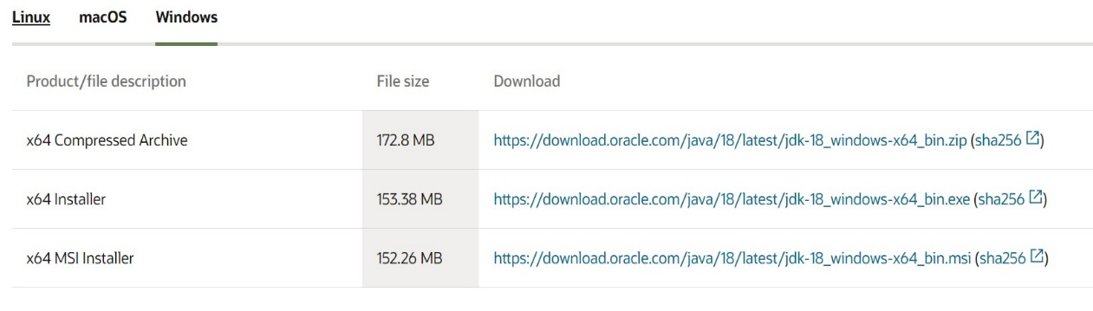

1. Download and install .

Lesson 2 : Our First java code

(Printing “Hello World Program” )

* Creating a Hello World Program in Java is not a single line program. It consists of various other lines of code. Since Java is a Object-oriented language so it require to write a code inside a class. Let us look at a simple java program.

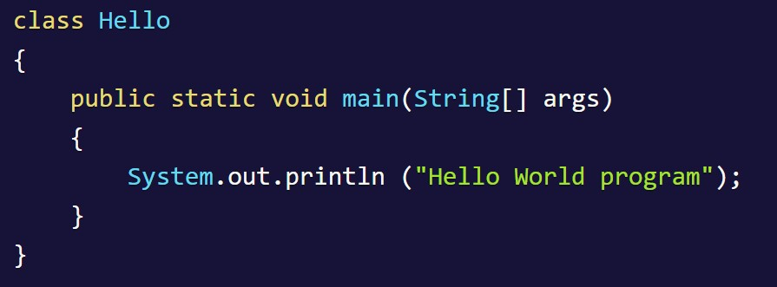

* Lets understand what above program consists of and its keypoints.
* **class :** class keyword is used to declare classes in Java.
* **public** : It is an access specifier. Public means this function is visible to all.
* **static** : static is again a keyword used to make a function static. To execute a static function you do not have to create an Object of the class. The **main()** method here is called by JVM, without creating any object for class.
* **void** : It is the return type, meaning this function will not return anything.
* **main** : main() method is the most important method in a Java program. This is the method which is executed, hence all the logic must be inside the main() method. If a java class is not having a main() method, it causes compilation error.
* **String[] args** : This represents an array whose type is String and name is args. We will discuss more about array in Java Array section.
* **System.out.println** : This is used to print anything on the console .
* **Steps to Compile and Run your first Java program By Your own .**

1. **Open Notepad** .

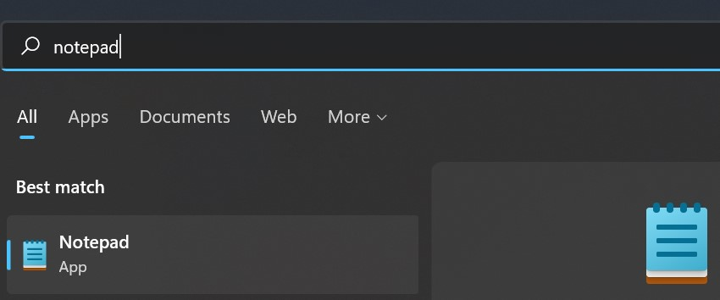

1. **Write the code as above.**

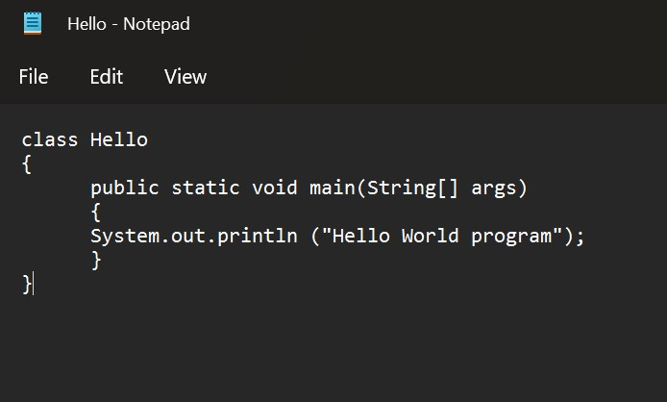

1. **Save the file as- Hello.java**

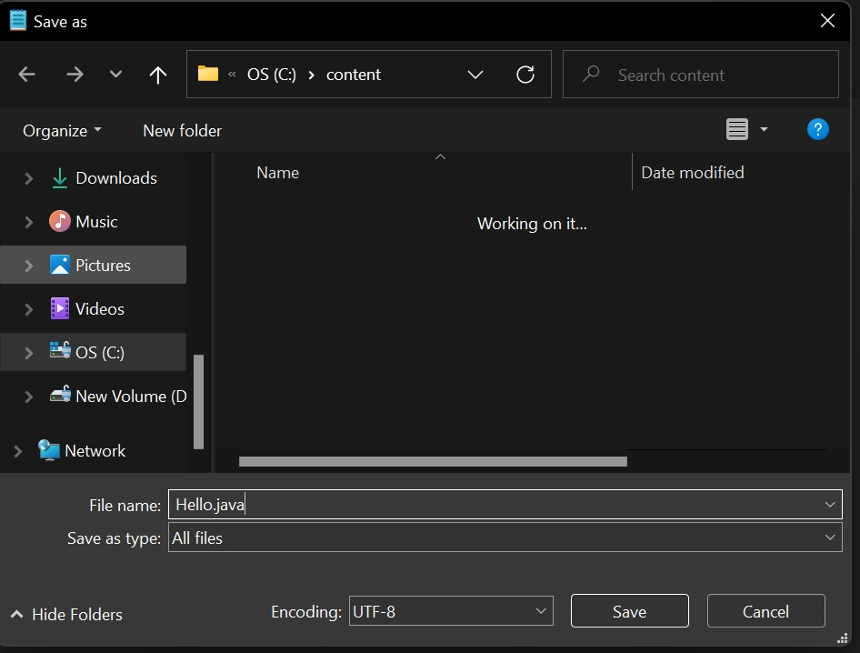

1. **Open command prompt(cmd) and go to the directory where you saved your first java program assuming it is saved in C drive.**



1. **Type javac Hello.java and press Return(Enter KEY) to compile your code. This command will call the Java Compiler asking it to compile the specified file. If there are no errors in the code the command prompt will take you to the next line.**



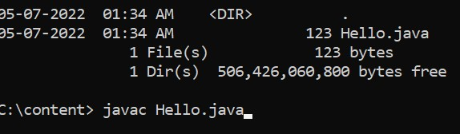

1. **Now type java Hello on command prompt to run your program.** You will be able to see **Hello world program** printed on your command prompt.

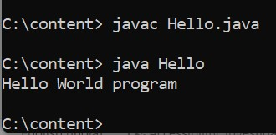

Lesson 3 :Practice by Yourself

1. Print your name .
2. Print your Address .
3. Print few lines about Your School.